Lab Class: Creating a Basic Three-Page Website
Table of Contents
Preparation
Files retained from the last Lab Class
Based on the Lecture Slides and Support Material
Adding a Proper Navigation Bar
Passing Data to a View
Passing an Array to a View
Iteration using Blade @foreach
Refactoring code
Adding Attributes
Using Array helpers
Files to retain for next Lab Class
Mini Challenges

Preparation
For practice, recreate the initial myFirstProject and replace or recreate the files from the previous Lab session.

Files retained from the last Lab Class
Replace the files
web.php
views folder

Based on the Lecture Slides and Support Material
You may watch the following videos for step-by-step demo
https://laracasts.com/series/30-days-to-learn-laravel-11/episodes/4
The fourth episode of the "30 Days to Learn Laravel 11" series focuses on the basics of how to link from page to page, adding style using TailwindCSS and its components:
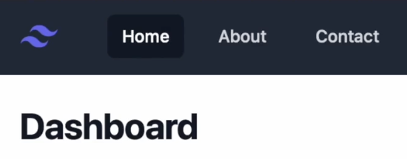
https://laracasts.com/series/30-days-to-learn-laravel-11/episodes/5
The fifth episode of the "30 Days to Learn Laravel" you will learn to add styling to the navigation link that matches the current page. Laravel provides a request object to help.
https://www.youtube.com/watch?v=mQHcDXYHUwY&t=679s
Learn how to pass an array of data as the second argument of the view() function. Each key in this array will then be extracted into a variable within your view.

Adding a Proper Navigation Bar
Continue working with your project that you have created in the previous session.

Go the following link and copy the HTML
https://tailwindui.com/components/application-ui/application-shells/stacked
Delete the following selected part of the code in the layout file and paste your copied HTML here.
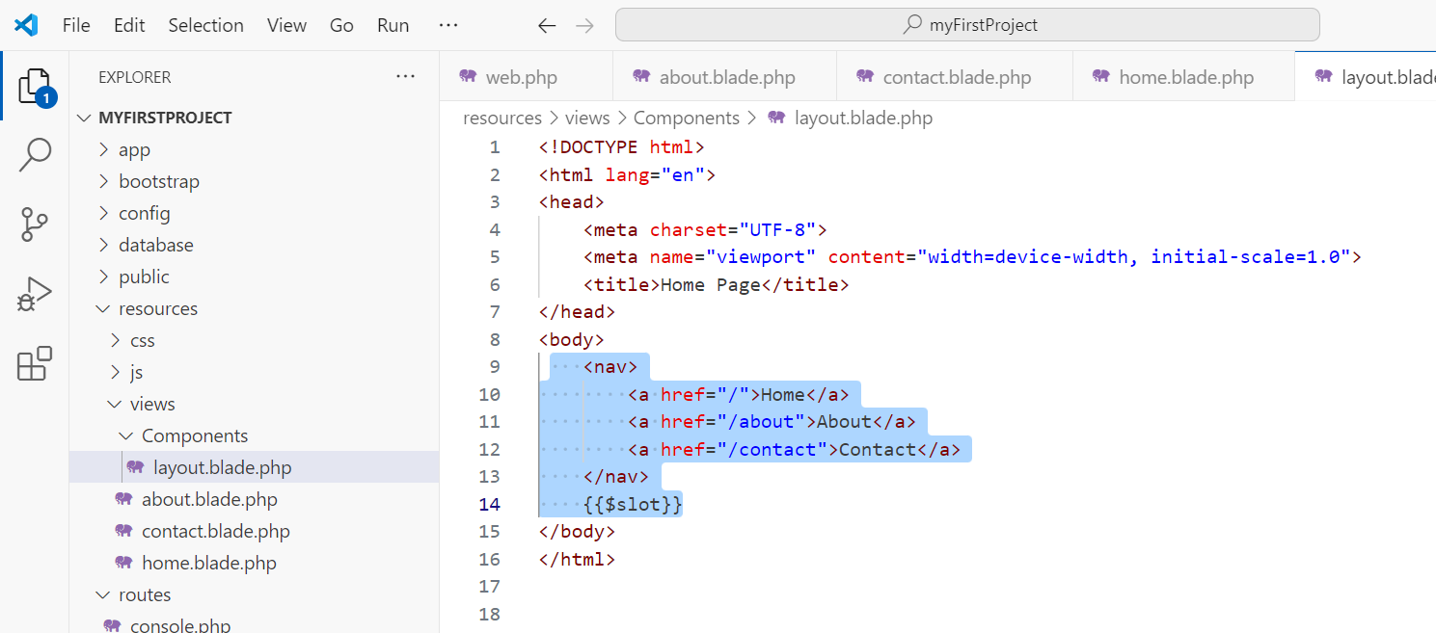
Paste the following code in the given location as shown below
<script src=https://cdn.tailwindcss.com></script>

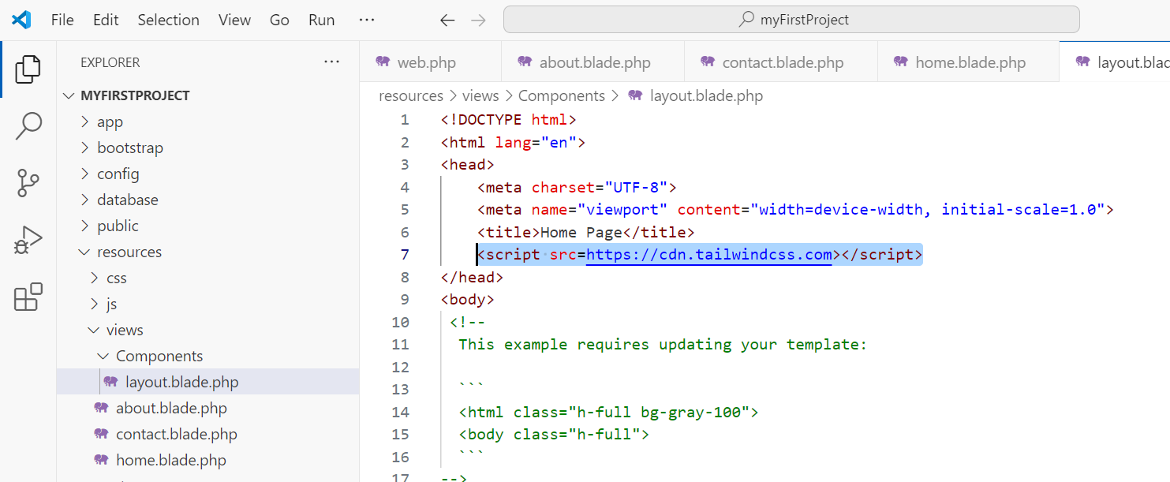

Delete the following code which is not relevant.
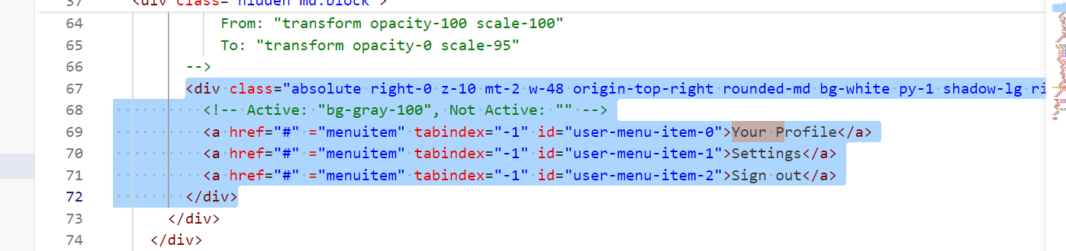

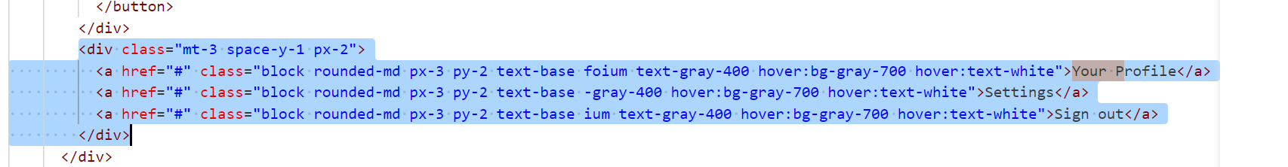

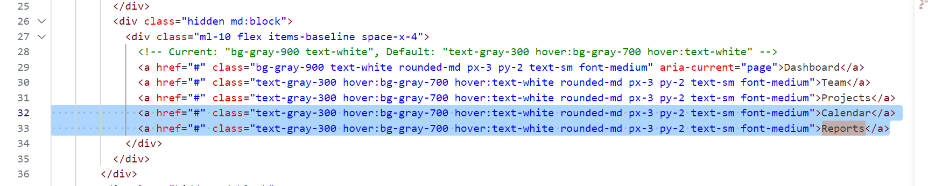

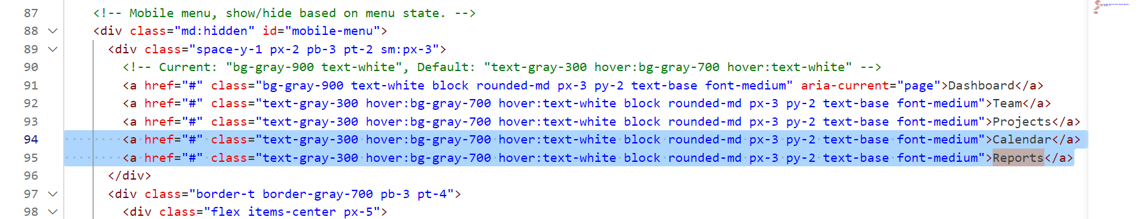

Modify the following sections as follows.
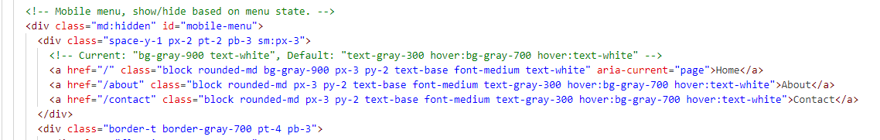
Display the slot value near the end of the file, as shown below
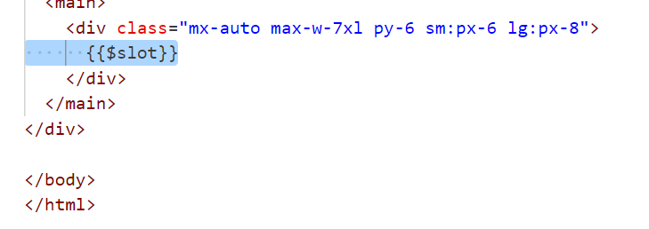
Test your application from the browser.
We can do the same for the heading:
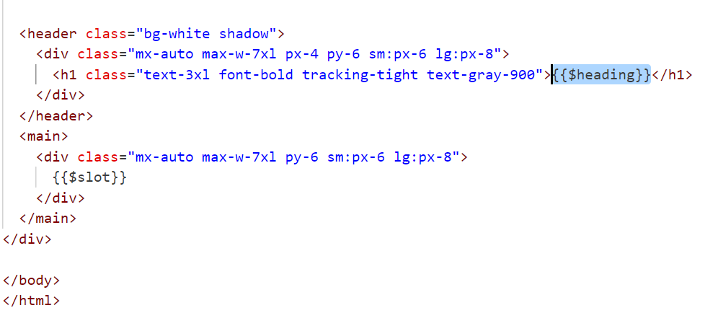
Modify the home, contact, and about views as follows
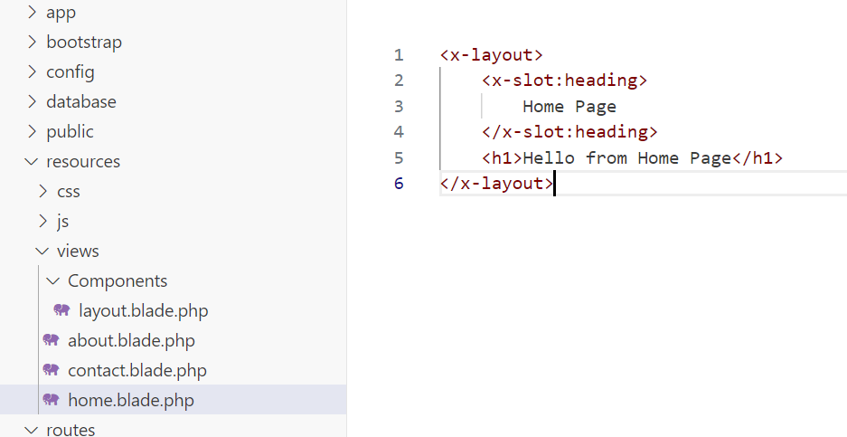
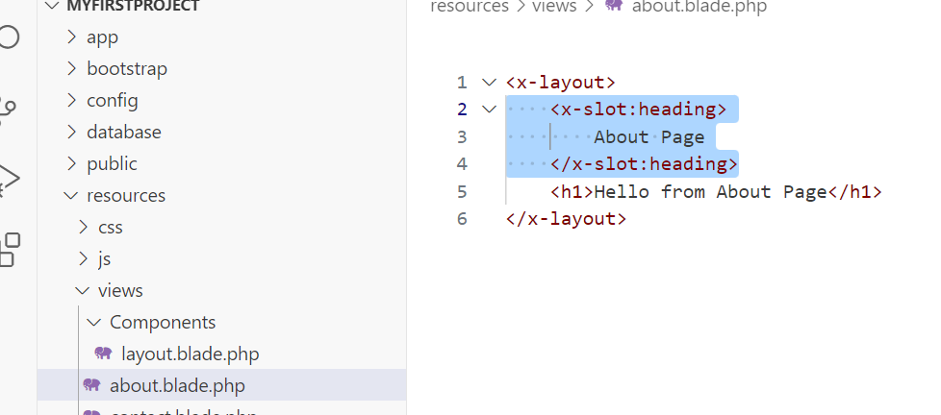

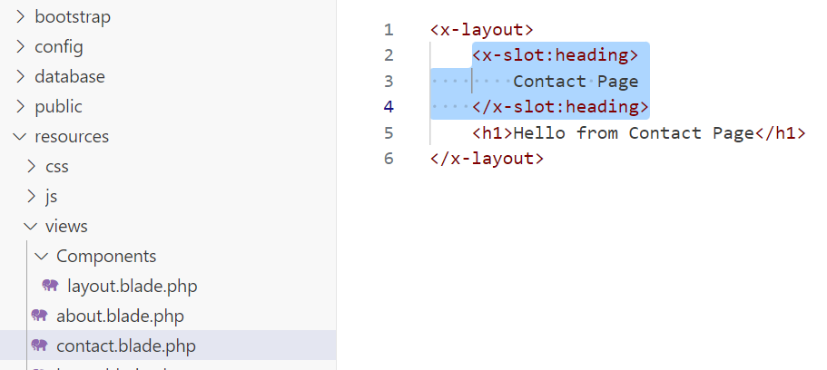

Let’s change the style to full
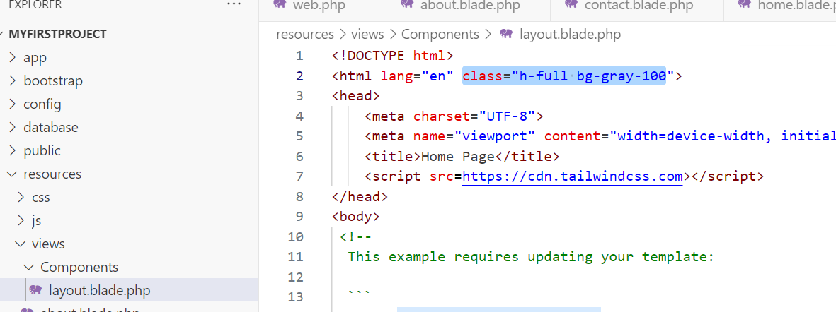

Replace the following three lines with the ones given below
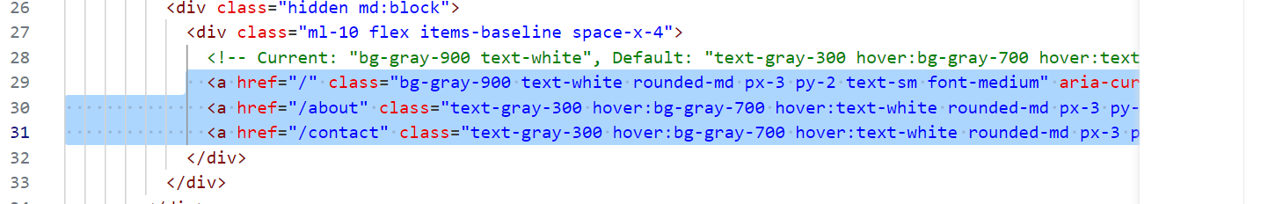
<x-nav-link href="/" :active="request()->is('/')">Home</x-nav-link>
<x-nav-link href="/about" :active="request()->is('about')">About</x-nav-link>
<x-nav-link href="/contact" :active="request()->is('contact')">Contact</x-nav-link>

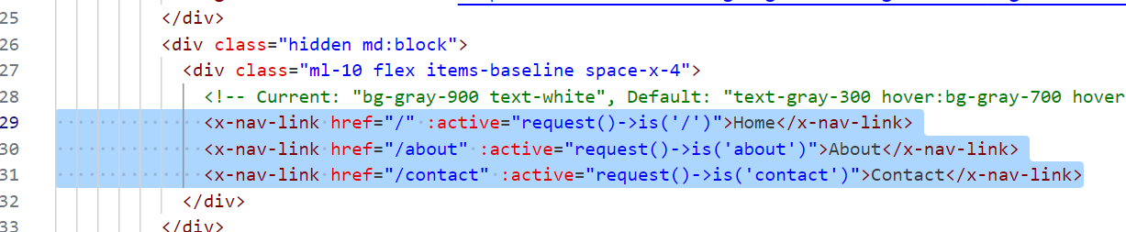

Create a new file nav-link.blade.php and fill it in with the following code
@props(['active'=> false])
<a class="{{$active ? 'bg-gray-900 text-white': 'text-gray-300 hover:bg-gray-700 hover:text-white'}} rounded-md px-3 py-2 text-sm font-medium"
aria-current={{$active ? 'page': 'false'}}
{{$attributes}}
>{{$slot}}</a>

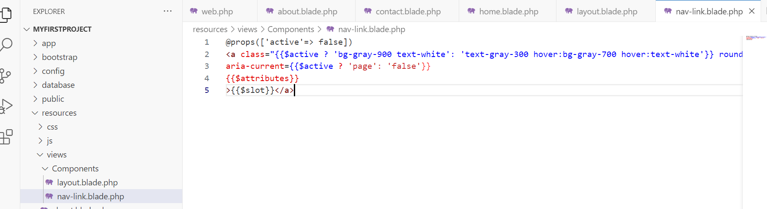

Passing Data to a View
Let’s pass data to a View
Add the selected text to the web.php. Now a variable named greeting is passed to the ‘home’ view
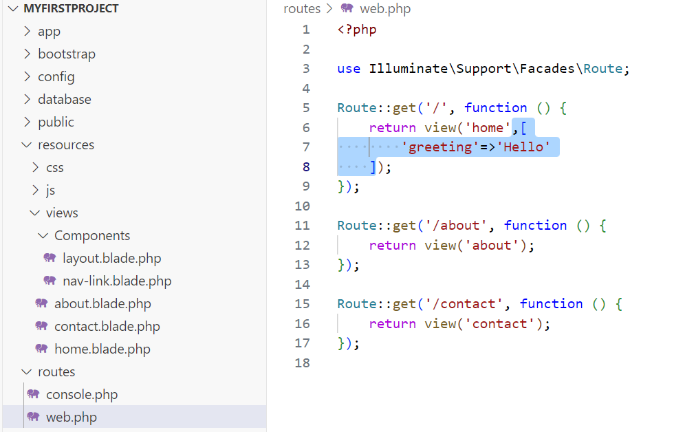
Here is how we can access the greeting variable in the ‘home’ view
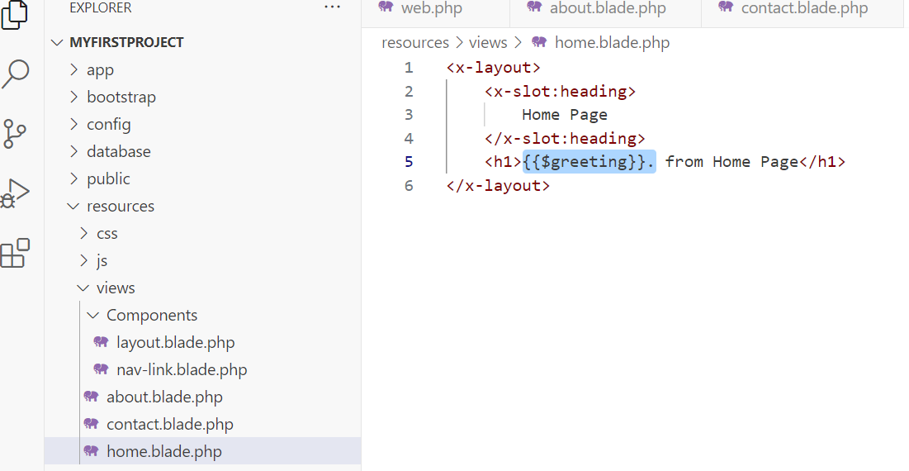

Passing an Array to a View
Now let’s pass multiple items (an array). Add the following code to web.php
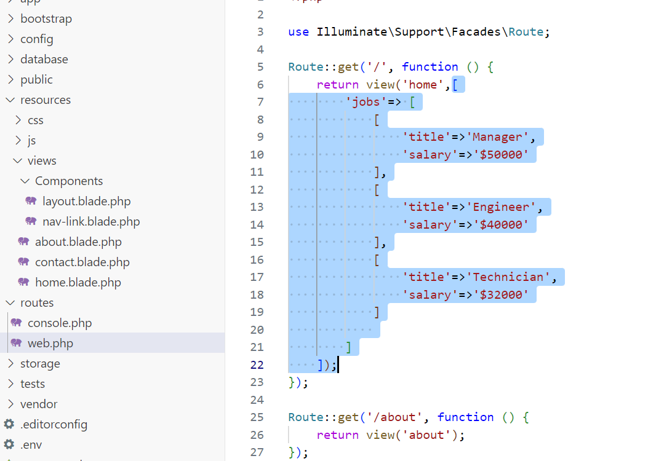

Iteration using Blade @foreach
Add the following code to home.blade.php
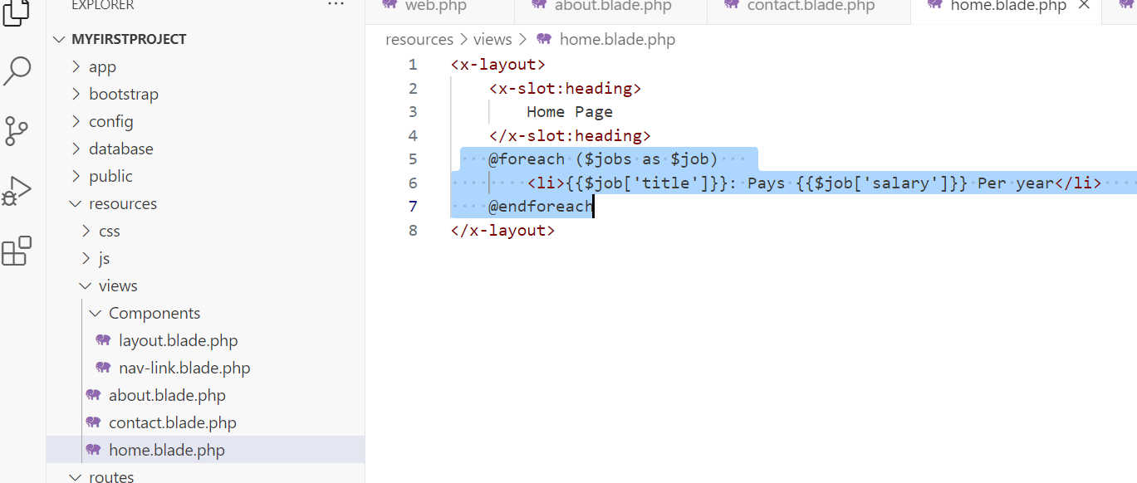
Save all, and test your application.
Now, let’s make the things more systematic.

Refactoring code
Change name of about.blade.php to jobs.blade.php
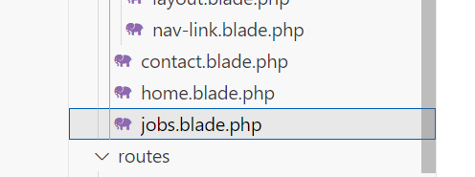
Change the ‘About’ to ‘Jobs’ in the layout.blade.php as well
<x-nav-link href="/jobs" :active="request()->is('Jobs')">Jobs</x-nav-link>

Change the code in jobs.blade.php as follows:
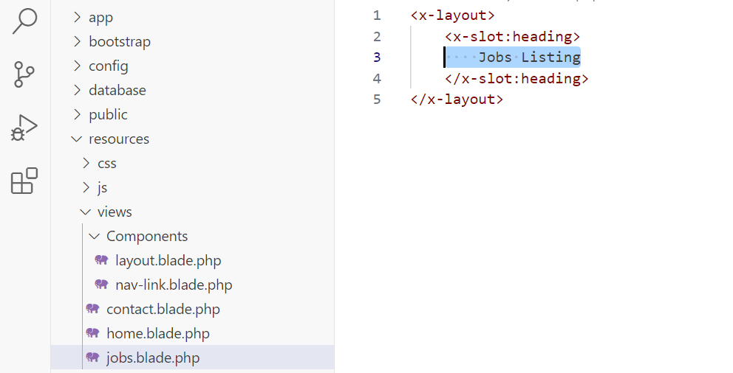

Do the relevant changes in the web.php as follows:
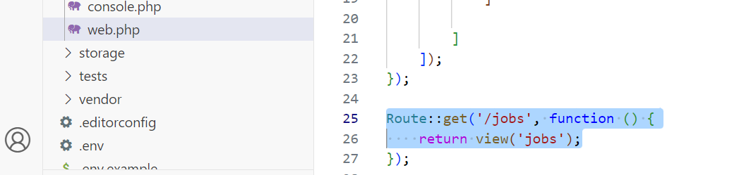
Shift the job listings to the jobs route as follows
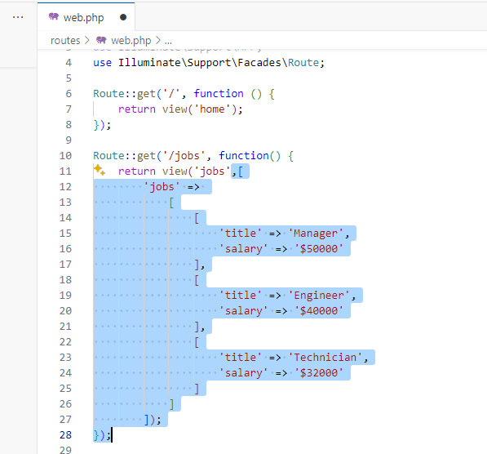

Go to home.blade.php and cut the @foreach section and paste it in the jobs.blade.php
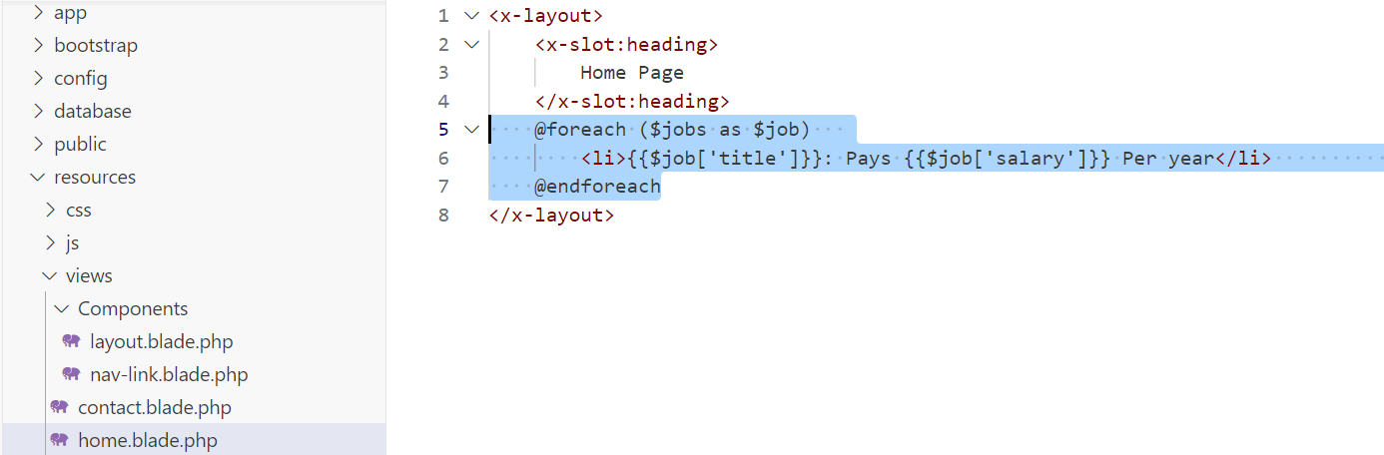

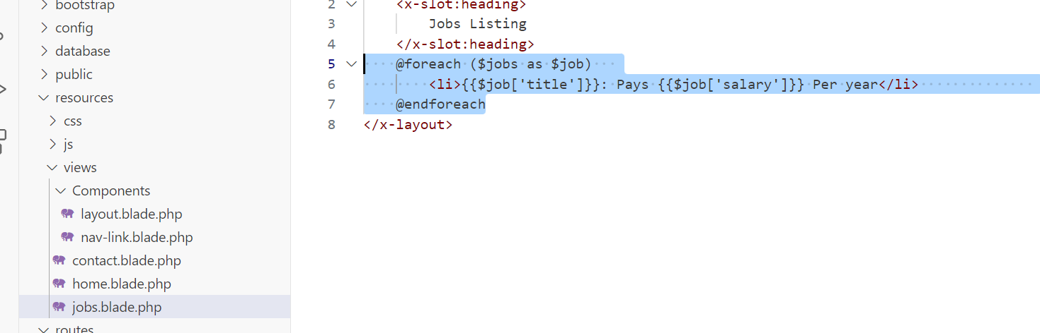
Save all and test your application.

Adding Attributes
Add ids for each job listing as follows
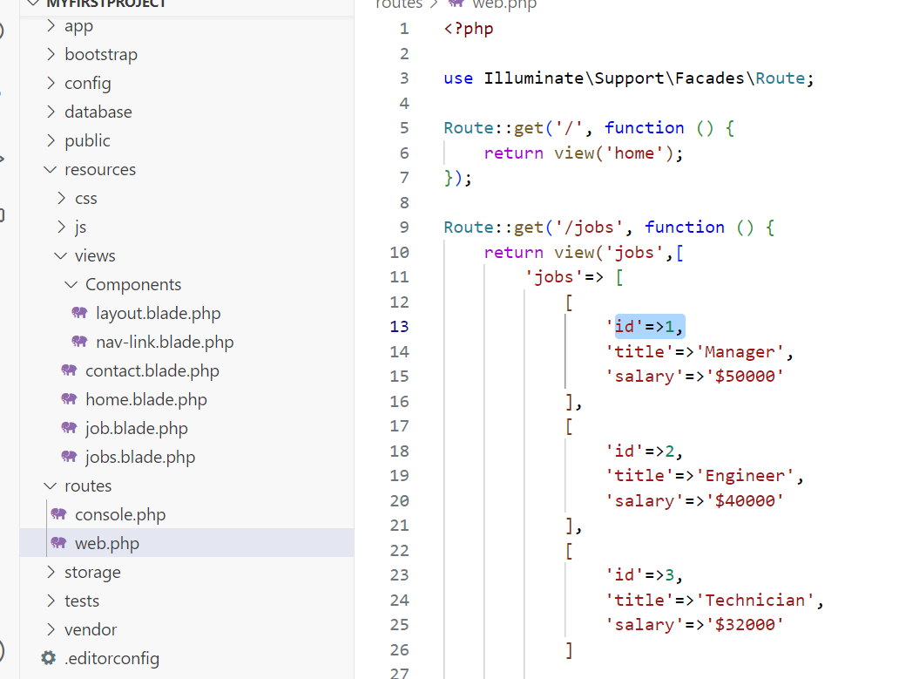
Create a new view with the name job.blade.php and populate it with the following code
<x-layout>
<x-slot:heading>
Job
</x-slot:heading>
<h2 class="font-bold txt-lg">{{$job['title']}}</h2>
<p>
This job pays {{$job['salary']}} per year
</p>
</x-layout>

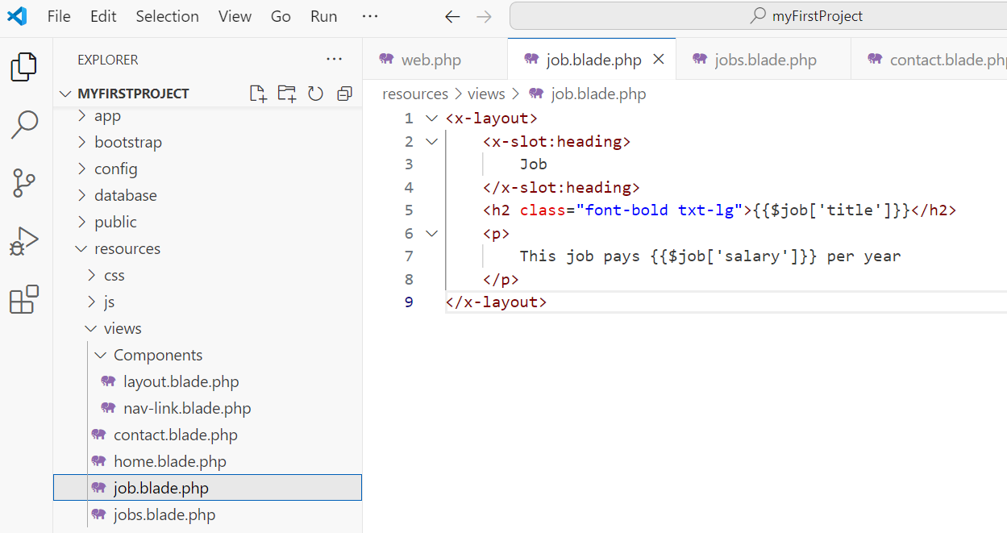

Modify the jobs.blade.php as follows
<x-layout>
<x-slot:heading>
Jobs Listing
</x-slot:heading>
<ul>
@foreach ($jobs as $job)
<li>
<a href="/jobs/{{$job['id']}}" class="text-blue-500 hover:underline">
<strong>{{$job['title']}}</strong>: Pays {{$job['salary']}} Per year
</a>
</li>
@endforeach
</ul>
</x-layout>

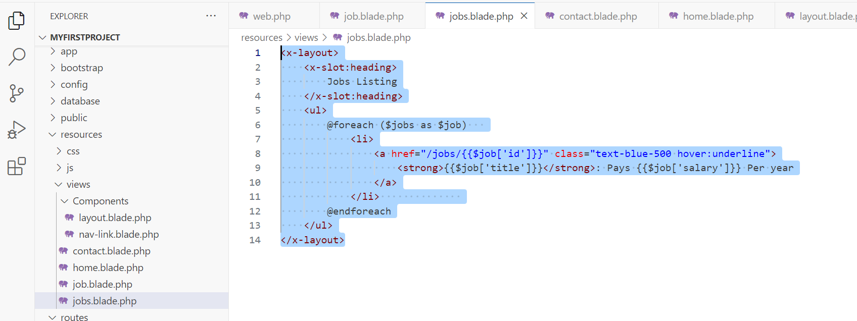

Using Array helpers
Add the following route to the web.php
Route::get('/jobs/{id}', function($id) {
$jobs=[
[
'id'=>1,
'title'=>'Manager',
'salary'=>'$50,000'
],
[
'id'=>2,
'title'=>'Engineer',
'salary'=>'$40,000'
],
[
'id'=>3,
'title'=>'Assisstant',
'salary'=>'$30,000'
]

];
$job=\Illuminate\Support\Arr::first($jobs, function ($job) use ($id) {
return $job['id']==$id;
});
return view('job',['job'=>$job]);

});

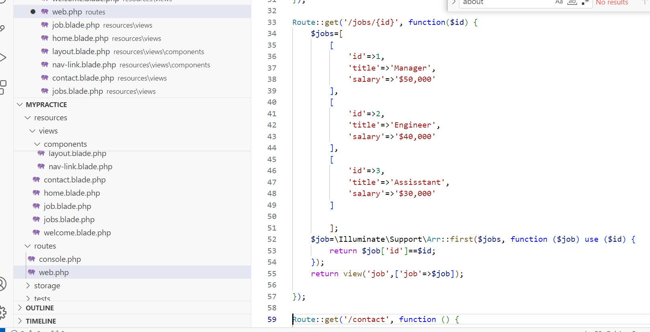
Save and test.

Files to retain for next Lab Class
web.php
views folder

Mini Challenges
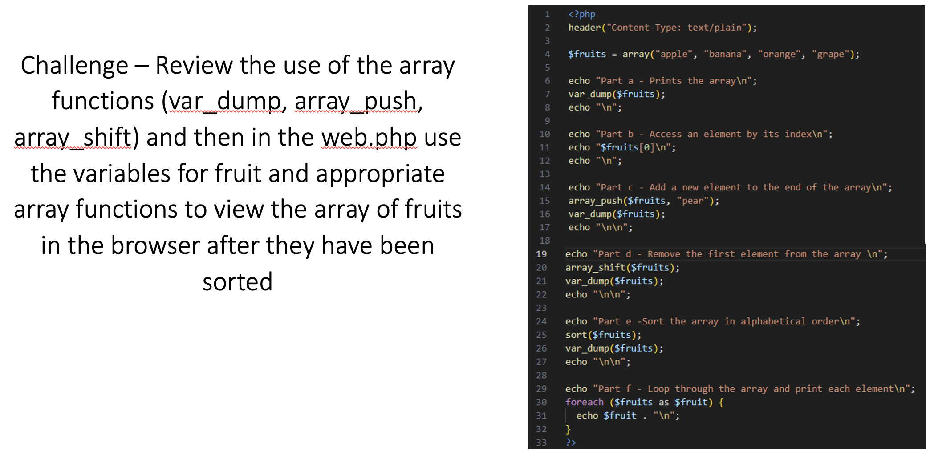
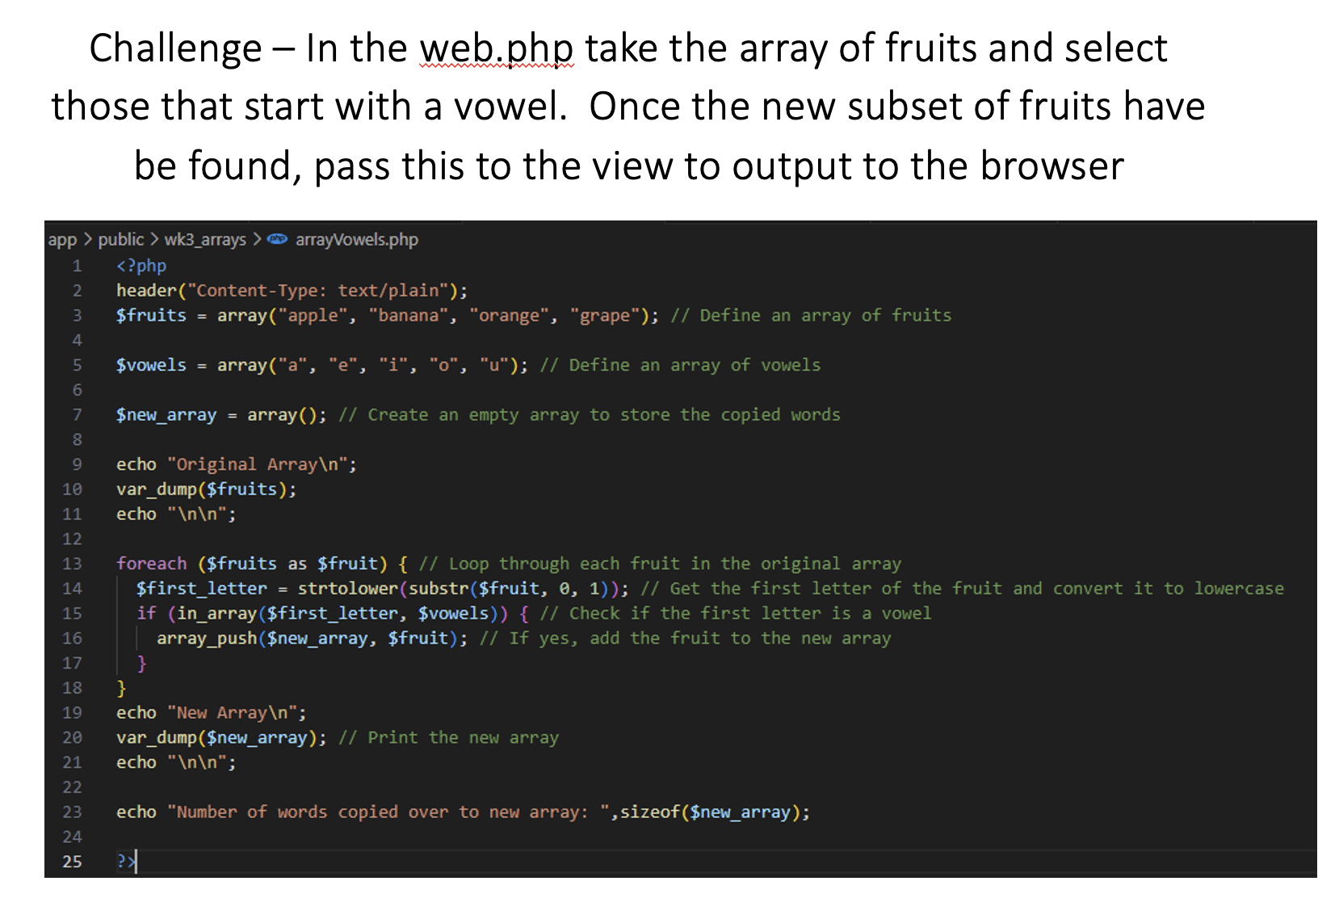
Challenge: Update your navigation template to use your own SVG logo and name.
Hint: use https://pixabay.com/vectors/search/navigation/ for free to use SVG’s

